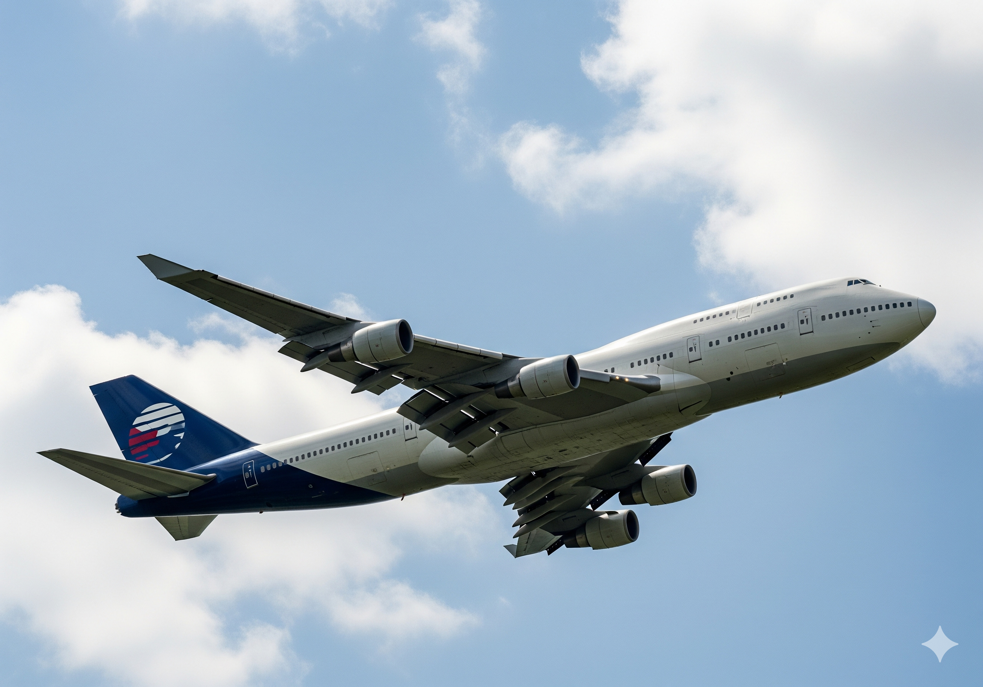  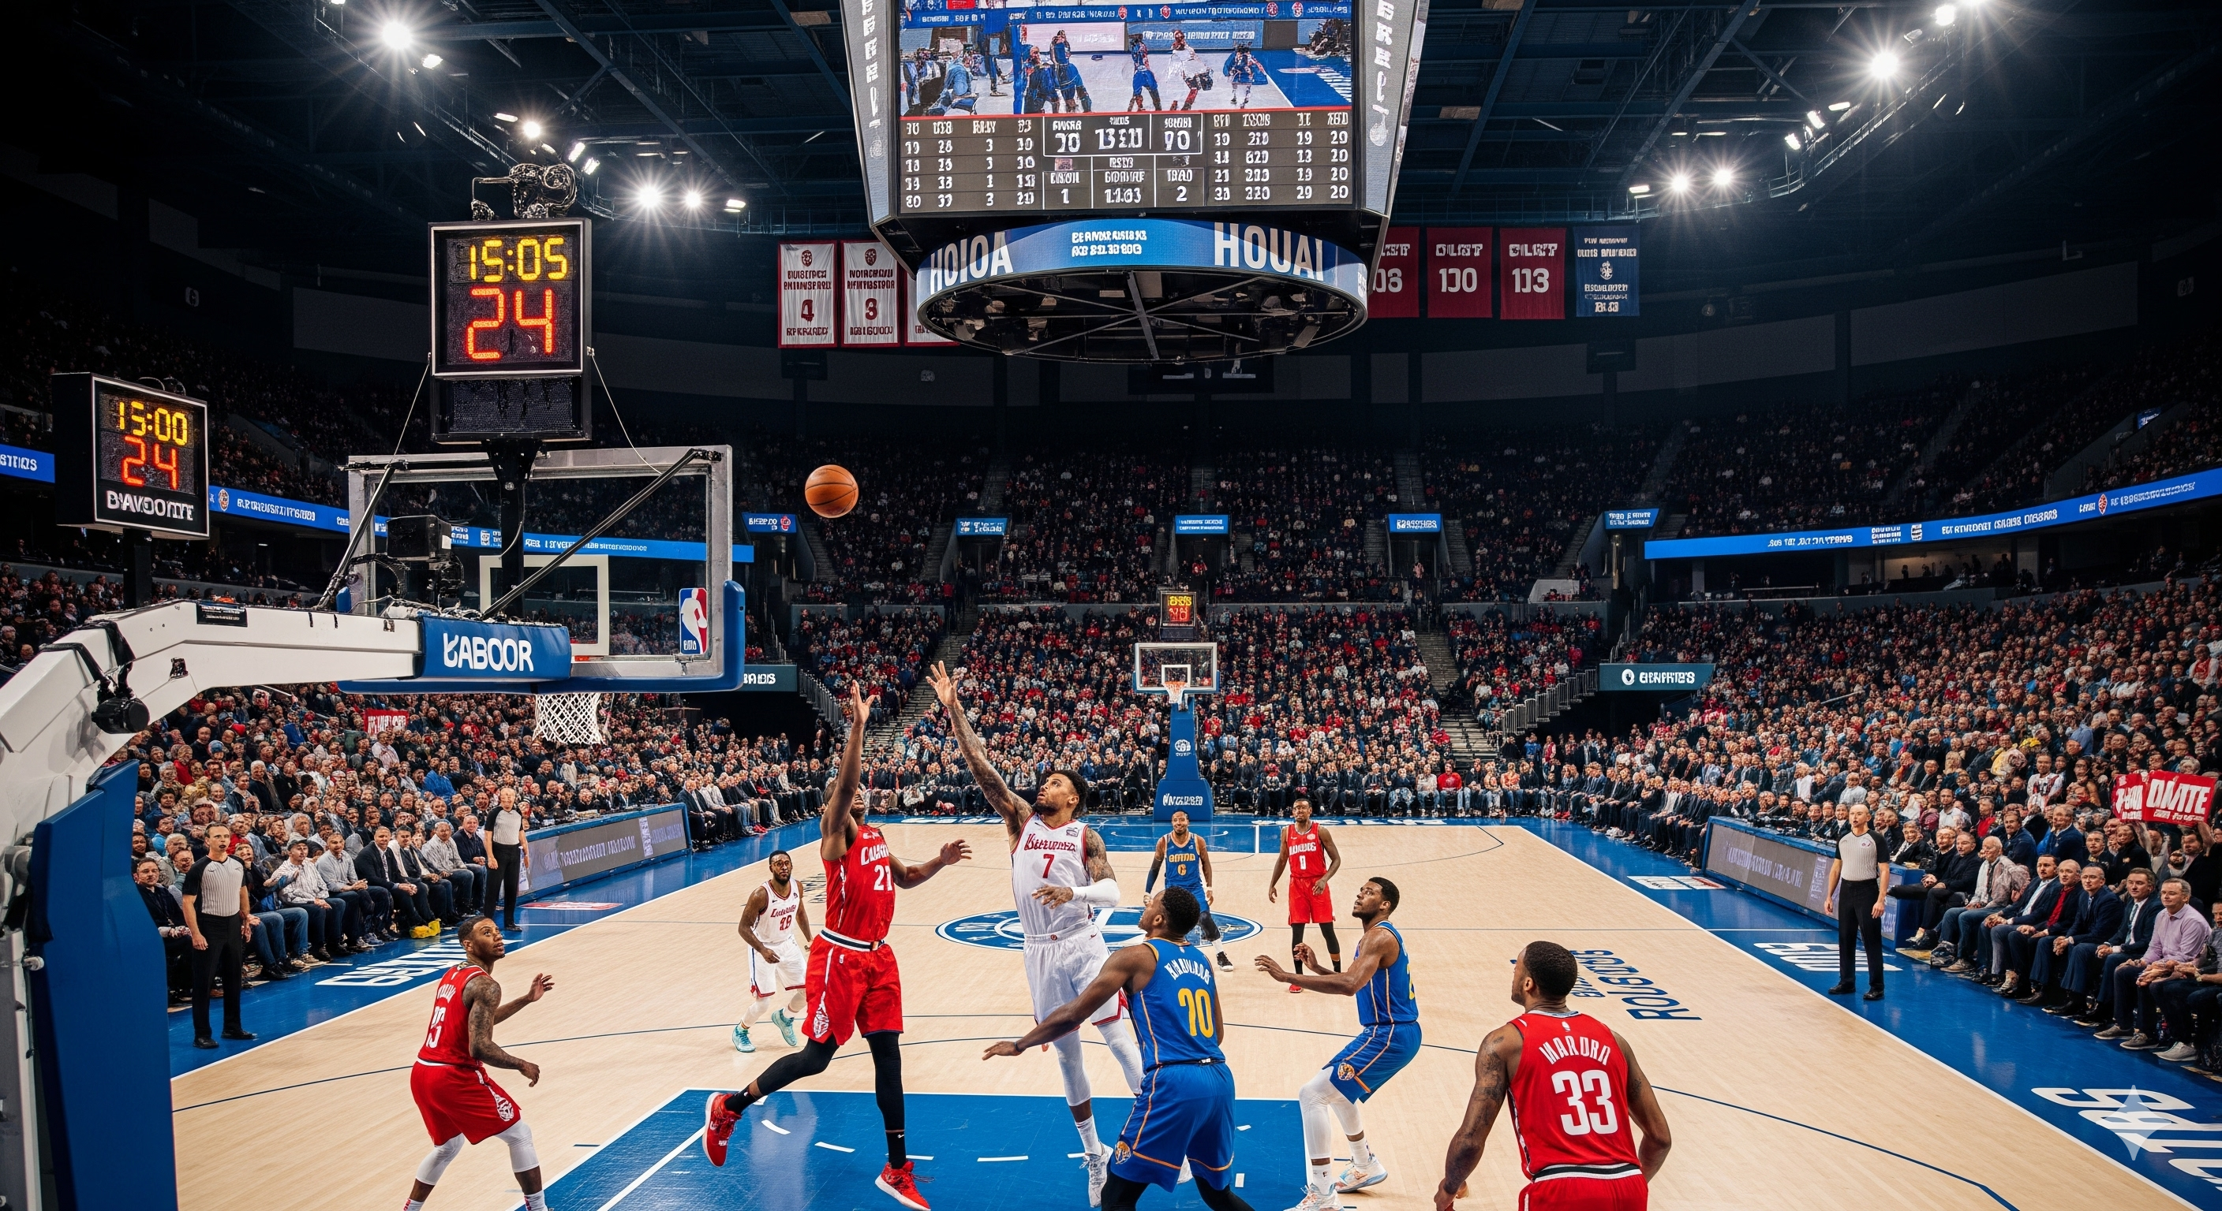

I **am** flying on an airplane today.

They **are** playing volleyball match.

We **are** playing volleyball match .

You **are** playing volleyball match .

She **is** running on the path.

He **is** running on the path.

It is a shiny day, so they are running.